Ventilation and Indoor Air Quality in Residential Bedrooms

Hagen Fritz Kerry Kinney, PhD David Schnyer, PhD

Student Member ASHRAE

Atila Novoselac, PhD Zolta Nagy, PhD

Associate Member ASHRAE Associate Member ASHRAE

Abstract

Few studies have investigated human exposure to indoor air pollutants during sleep even though humans spend about a third of the day asleep in the same environment. In this study, we use consumer-grade sensors to measure key indoor air pollutants and use carbon dioxide to estimate ventilation rates so that we can better understand the human sleep microenvironment. We developed a sensing platform capable of measuring light levels, temperature, relative humidity, carbon dioxide, particulate matter (PM2.5 and PM10), total volatile organic compounds, carbon monoxide, and nitrogen dioxide. The device was distributed to 29 university students living in Texas from early June to early September 2020. Data were collected continuously at 1-minute intervals in their bedroom environments. Participants were also provided a wristband to be worn at all times. The wristband was used to determine when participants were asleep which allowed us to limit the data analysis to truly sleeping times and exposure. A survey administered at the beginning of the study period provided insight into the home environment including questions regarding roommates, pets, cooking habits, air filter use, etc. which provides context to the collected data.

introduction

Sleep is important.

Methodology

This research project was a subset of a larger study aimed at understanding student’s behaviors and environmental exposures throughout the course of their day using numerous affordable and mobile sensing technologies. However, the scope of the project is limited to devices, variables, and participants that were studied in order to help address environmental exposures in participants’ bedrooms.

Student participants were recruited from the University of Texas at Austin (UT) and underwent an initial screening before being consented into the study. Enrollment interviews that consisted of researcher-guided surveys to better understand the individual and their behaviors were conducted over a period of two weeks with full enrollment completed by May 1st, 2020. A total of 71 participants were initially enrolled with two participants opting to drop out during the course of the study. The study concluded when participants scheduled a virtual meeting with a study coordinator in early September 2020 for an exit interview and to coordinate shipping study materials back to the university.

Environmental Quality Monitoring

To get an initial impression of the environment participants lived in, a one-time virtual survey called Environment and Experiences (EE) was administered asking various questions regarding pollutant exposures at home (smoking/vaping, pets, floor type, etc.) and cleaning habits (portable air cleaner use, disinfecting practices, etc.). To monitor the indoor environmental quality (IEQ) of the participants’ bedrooms during the study period, we developed, calibrated, and deployed our own monitoring device called the Building EnVironment and Occupancy (BEVO) Beacon. Due to production limitations and calibration issues, only 29 devices were sent to a subset of the 71 participants. The BEVO Beacon, pictured in Figure 1, includes a Raspberry Pi 3B+ (RPi) wired to six affordable, commercially available sensors; one 250 mm X 250 mm (1” X 1”) cooling fan; and a batteried-powered clock to keep time when the device is not connected to WiFi. Within the BEVO Beacon, the RPi is housed in a separate chamber from the sensors where the fan provides air to help cool the RPi processor. All six sensors are either exposed directly to the air or have inlets that pull from outside the wooden housing. The sensos on the BEVO Beacon measure temperature, relative humidity (RH), light levels, carbon dioxide (CO2), particulate matter with aerodynamic diameters of 2.5 (PM2.5) and 10 (PM10) micrometers, total volatile organic compounds (TVOCs), nitrogen dioxide (NO2), and carbon monoxide (CO). Each sensor attempts to take 5 readings over a period of 10 seconds, logs the average of these readings, and then sleeps for 50 seconds providing data at a one-minute resolution. Data are stored locally on the RPi but can be accessed remotely if the BEVO Beacon is connected to WiFi.

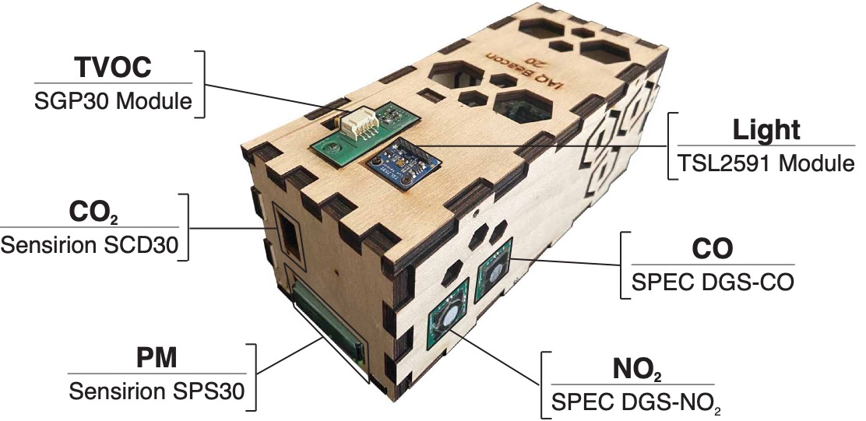

Figure 1. The BEVO Beacon and the 6 sensors, the primary variable they measure, and the sensor name.

The BEVO Beacon were sent out on a rolling basis starting June 1st, 2020 with the first device reaching its destination on June 3rd. Deployment was delayed because of calibration issues and logistical issues regarding shipment of the devices during the SARS-CoV-2 pandemic. Upon arrival, participants were asked to plug in the devices immediately. Some participants opted to delay plugging in the devices or unplugged them before the study ended in September. The BEVO Beacons were returned on a rolling basis starting September 1st, 2020.

Mobile Sensing

As part of the study, all 71 participants were asked to download and use the Beiwe smartphone application. The Beiwe Research Platform [] provides digital phenotyping in the form of data collected from smartphone sensors and responses from Ecological Momentary Assessments (EMAs) that researchers can schedule and send via the app. At the enrollment interview, students were given login credentials created by the research team that would connect them to the project’s server. Data collected by the app are periodically pushed to the secure server accessible by the reserachers to monitor participation and data collection.

Fitbit Inspire HR devices were distributed to the same 29 participants who received the BEVO Beacon. Participants were asked to create or use their existing accounts, which were linked to a Fitabase server to securely store and allow researchers to monitor the data collected. This particular model of Fitbit includes a heart rate monitor in addition to the standard accelerometer which helps to more accurately track the wearer’s sleep.

Pre-Processing IEQ Data

The BEVO Beacon, once powered on, continuously monitors the environment. However, for this study we were only interested in data collecting during periods when participants were home and in their bedrooms. Fitbit logs sleep data, including the start and stop time, for any sleep event that the device detects lasting a minimum of 3 hours. We can use the start and stop timestamps to restrict the IEQ data from BEVO Beacons to only these periods. However, we cannot guarantee that participants are sleeping in the same environment that the BEVO Beacon is monitoring. To do so, we can cross reference the addresses provided by the participants with the GPS traces logged by the Beiwe app. By comparing the longitude and latitude values measured by Beiwe to those corresponding to the participants’ addresses, the IEQ data can be futher filtered so as to only include nights when the participants were asleep at their homes i.e. the same location the BEVO Beacon is monitoring.

Ventilation Estimates

Ventilation in the spaces can be estimated under two conditions: (1) a constant CO2 concentration is reached for an extended period or (2) an uninterrupted decay of CO2 concentrations corresponding to when participants leave their bedrooms. In either case, a simple mass balance is used to represent the space:

$$V\frac{dC}{dT}=pQC_{0}-QC+E$$

Where $V$ is the volume, $p$ is the penetration factor for CO2, is the flow rate into and out of the space, $C_{0}$ is the outdor CO2 concentration, $C$ is the indoor CO2 concentration, and is the CO2 emission rate. Considering the first case when CO2 concentrations are constant, Eq. 1 simplifies as the rate terms goes to zero. After rearranging:

$$λ=\frac{E}{V\left(C- pC_{0}\right)}$$

Where $λ$ is the air exchange rate defined as $\frac{Q}{V}$ and is the variable we are interested in determining.

The second condition is more complicated since the rate term in Eq. 1 is still included which requires integration to solve. The final equation for an inert gas such as CO2 is given by:

$$C_{t}=C_{t=0}e^{-λt}+\left(pC_{0}+\frac{E}{λV}\right)\left(1-e^{-λt}\right)$$

To solve Eq. 3 for $λ$ we must employ an iterative solution where $λ$ is systematically vaied until we minimize the difference between the measured CO2 concentrations and the concentrations, $C_{t}$, calculated by Eq. 3. Under either scenario, we must use the CO2 concentrations measured by the BEVO Beacon, calculate $E$ for each participant, and make a few key assumptions about the remaining variables.

The CO2 emission rate, $E$, was calculated adapting the model presented in Persily and Jonge (2016). The model requires knowledge of the participants body-mass-ratio ($BMR$), and the temperature and pressure in the space. The $BMR$ is dependent on the age, sex, and weight of the individual, which we know from the enrollment surveys (age and sex) and Fitbit (weight). We can use the average temperature measured by the BEVO Beacon during either the constant CO2 or decay periods and can assume the pressure is constant at sea level conditions.

For the remaining values, we assumed the following: $p$ is equal to 1, $C_{0}$ is 400 ppm, and $V$ is constant but varies depending on the type of housing the participant lives in. For participants in apartments, we used dimensions of 3 m X 3.4 m X 2.7 m (10’ X 11’ X 9’) whereas for those living in stand-alone houses, we approximated the bedroom dimensions as 3.4 m X 3.6 m X 2.7 m (11’ X 12’ X 9’). Participants did not provide the layout of their bedrooms but did indicate their housing type in the EE survey.

Results and Discussion

Of the 29 BEVO Beacons deployed, 26 were returned with usable data. The clock on one device was disconnected in the initial transit and therefore the timestamps on all the data were incorrect. Since we are not able to know the exact time the participants powered on their device, there is no way to correct the timestamps. Of the other two devices, one was never powered on and the other recorded data for less than 1 day. The following sections only consider the data measured by the 26 working devices.

Data Completeness

Data were first downsampled to five-minute averages since delays associated with connecting to individual sensors caused measurements to be made at inconsistent time intervals rather than at each minute. Data completeness can be viewed in two ways: (1) amount of data collected over the period during which individuals had their BEVO Beacon devices or (2) amount of data collected over the period when BEVO Beacons were powered on. We present the results for both in Table 1 separated by sensor. The first two columns consider data collected during all hours of the day.

Considering all participants, there were a total of X nights during the study period. Of these nights, we can be sure Y of them were when participants were home and asleep according to the GPS and Fitbit data. We include a third column in Table 1 highlighting the percentage of data collected by each sensor for these Y nights.

Table 1. Data Completeness by Sensor

|  |  |  |  |
| --- | --- | --- | --- |
|  | Percentage of Data Collected: | | |
| During study period | While device is operating | When participants are sleeping at home |
| Light |  |  |  |
| TVOC |  |  |  |
| CO2 |  |  |  |
| CO/T/RH |  |  |  |
| NO2/T/RH* |  |  |  |
| PM |  |  |  |
| Total |  |  |  |

* Only 11 of the 26 BEVO Beacons summarized in this table had this sensor – results for this sensor only include these 11 BEVO Beacons

Summary of Data Collected

A summary of the aggregate data collected by the BEVO Beacons during the evenings when participants were home and asleep is shown in Table 2.

Table 2. Summary of Data from All BEVO Beacons

|  |  |  |  |  |  |  |  |  |  |
| --- | --- | --- | --- | --- | --- | --- | --- | --- | --- |
|  | n | mean | median | minimum | 25% | 75% | maximum | skewness | kurtosis |
| Light (lux) | 11332 | 2.35 | 0.00 | 0.00 | 0.00 | 0.21 | 74.91 | 4.53 | 25.09 |
| T (°F/°C) | 12063 | 26.97 | 27.00 | 22.20 | 25.00 | 28.50 | 31.72 | -0.07 | -0.89 |
| RH (%) | 12193 | 42.58 | 42.00 | 30.80 | 39.56 | 45.00 | 62.93 | 0.78 | 1.48 |
| TVOC (ppb) | 12054 | 270.29 | 244.40 | 0.00 | 186.53 | 332.40 | 1393.20 | 1.86 | 7.27 |
| CO2 (ppm) | 11701 | 951.06 | 877.23 | 100.2 | 734.11 | 1172.46 | 2281.53 | 0.72 | 0.44 |
| CO (ppm) | 12200 | 0.58 | 0.00 | 0.00 | 0.00 | 0.00 | 13.09 | 2.95 | 7.80 |
| NO2 (ppb) | 8186 | 112.52 | 75.12 | 0.00 | 66.44 | 111.84 | 646.48 | 3.58 | 12.94 |
| PM1 () | 12193 | 2.97 | 2.53 | 0.00 | 1.76 | 3.45 | 72.54 | 9.52 | 142.47 |
| PM2.5() | 12188 | 7.59 | 707 | 0.00 | 5.79 | 9.00 | 81.76 | 4.68 | 52.33 |
| PM10 () | 12181 | 11.85 | 11.24 | 0.00 | 9.46 | 14.13 | 92.66 | 2.42 | 22.43 |

Ventilation Rates

Conclusion

Acknowledgement